DESIGN AND IMPLEMENTATION OF A SECURE ENTERPRISE NETWORK USING VLANs AND INTER-VLAN ROUTING
Prepared By
SAMUEL OCHOCHE PETER
(FE/25/80300835222)
Cybersecurity Student
3MTT Cybersecurity Program
Project Title
Configuration of IP Addressing and Virtual Local Area Networks (VLANs) in a Simulated Enterprise Network Environment
Project Focus
• VLAN Design and Implementation
• Network Segmentation
• IP Addressing Configuration
• Inter-VLAN Routing
• Access Control Lists (ACLs)
• Network Security and Traffic Isolation
• Enterprise Network Management
Tools Used
• Cisco Packet Tracer
• Cisco Router
• Cisco Switch
• Windows Command Prompt
• Networking and Security Configuration Tools
Date: 8th June, 2026

INTRODUCTION
Modern organizations rely heavily on computer networks to support communication, data sharing, and access to critical business resources. As enterprise networks continue to grow in size and complexity, network administrators must implement effective strategies to improve security, performance, scalability, and manageability. One of the most widely used techniques for achieving these objectives is the implementation of Virtual Local Area Networks (VLANs).
A Virtual Local Area Network (VLAN) is a logical segmentation of a physical network that allows devices to be grouped according to business functions rather than physical location. VLANs help reduce broadcast traffic, improve network performance, enhance security, and simplify network administration. By separating departments into different VLANs, organizations can control communication between users and protect sensitive resources from unauthorized access.
In addition to VLAN implementation, organizations often require communication between separate network segments. This is achieved through Inter-VLAN Routing, a technique that enables devices in different VLANs to communicate while maintaining network segmentation. Inter-VLAN Routing provides controlled connectivity between departments and allows administrators to enforce security policies using routing and access control mechanisms.
This project focuses on the design and implementation of a secure enterprise banking network using Cisco Packet Tracer. The network is divided into multiple departments, including Customer Service, Accounts, Information Technology (IT), and ATM/Server Infrastructure. Each department is assigned a dedicated VLAN and IP subnet to achieve logical separation and improve security.
To further strengthen the network, Access Control Lists (ACLs) were implemented to restrict unauthorized communication between departments. Security policies were designed to prevent Customer Service users from accessing IT resources while allowing authorized communication between the Accounts Department and the ATM Server network.
The project demonstrates the practical application of VLAN segmentation, trunk configuration, IP addressing, Inter-VLAN Routing, and ACL-based security controls within a simulated enterprise environment. Various verification and testing procedures were performed to ensure that network communication, segmentation, and security requirements were successfully achieved.
The knowledge and skills demonstrated in this project are directly applicable to modern enterprise networks, financial institutions, government agencies, and other organizations that require secure, scalable, and well-managed network infrastructures.
PROJECT GOALS
The primary objective of this project was to design and implement a secure enterprise network using Virtual Local Area Networks (VLANs) and Inter-VLAN Routing. The project was developed in Cisco Packet Tracer to simulate a real-world banking environment where different departments require network segmentation, controlled communication, and enhanced security.
Specific objectives of the project include:
- Design a functional enterprise network topology using Cisco Packet Tracer.
- Implement VLANs to logically separate departments and reduce unnecessary broadcast traffic.
- Configure VLAN names and assign switch ports according to departmental requirements.
- Configure IP addressing schemes for all end devices and network interfaces.
- Implement Inter-VLAN Routing using the Router-on-a-Stick technique.
- Configure trunk links to allow multiple VLAN traffic between the switch and router.
- Apply Access Control Lists (ACLs) to enforce security policies and restrict unauthorized communication.
- Verify connectivity through ping tests and network troubleshooting tools.
- Demonstrate how network segmentation improves security, performance, and manageability in an enterprise environment.
- Gain practical experience with enterprise networking concepts used in modern organizations.
ASSET, THREAT, AND VULNERABILITY ANALYSIS
Asset Identification
Assets are valuable resources that require protection within the network environment. The following assets were identified in this project:
Network Infrastructure Assets
- Cisco Router
- Cisco Switch
- Trunk Links
- VLAN Interfaces
End User Assets
- Customer Service Department Computers
- Accounts Department Computers
- IT Department Computers
Critical Business Assets
• ATM Server
• Financial Records
• Customer Information
• Internal Banking Systems
Network Services
• Inter-VLAN Routing Services
• IP Addressing Services
• Internal Communications
Threat Identification
The following threats were identified as potential risks to the banking network:
Unauthorized Access
Attackers may attempt to access sensitive departments such as IT or Server networks without authorization.
Internal Threats
Employees may intentionally or unintentionally access restricted systems or confidential information.
Malware Propagation
A malware infection in one department may spread across the network if proper segmentation is not implemented.
Network Reconnaissance
Attackers may scan the network to identify active hosts, services, and vulnerabilities.
Denial of Service (DoS)
Attackers may attempt to overwhelm network resources and disrupt operations.
VLAN Hopping Attacks
Attackers may attempt to bypass VLAN boundaries and gain access to unauthorized network segments.
Data Theft
Sensitive customer information and banking records may be targeted for theft.
Vulnerability Identification
Before VLAN implementation, the network could be vulnerable to:
• Flat Network Architecture
• Excessive Broadcast Traffic
• Lack of Traffic Isolation
• Weak Access Control Mechanisms
• Unrestricted Communication Between Departments
• Increased Attack Surface

Risk Mitigation Measures
To reduce identified risks, the following security controls were implemented:
• VLAN Segmentation
• Inter-VLAN Routing
• Access Control Lists (ACLs)
• Departmental Traffic Isolation
• Controlled Network Access
• Secure Network Architecture
The implementation of these controls significantly improves confidentiality, integrity, and availability of network resources.
IP ADDRESSING PLAN
To ensure proper communication and network organization, each department was assigned a unique IP subnet and VLAN. This approach simplifies management and improves security through network segmentation.
Table 1: VLAN and IP Addressing Scheme
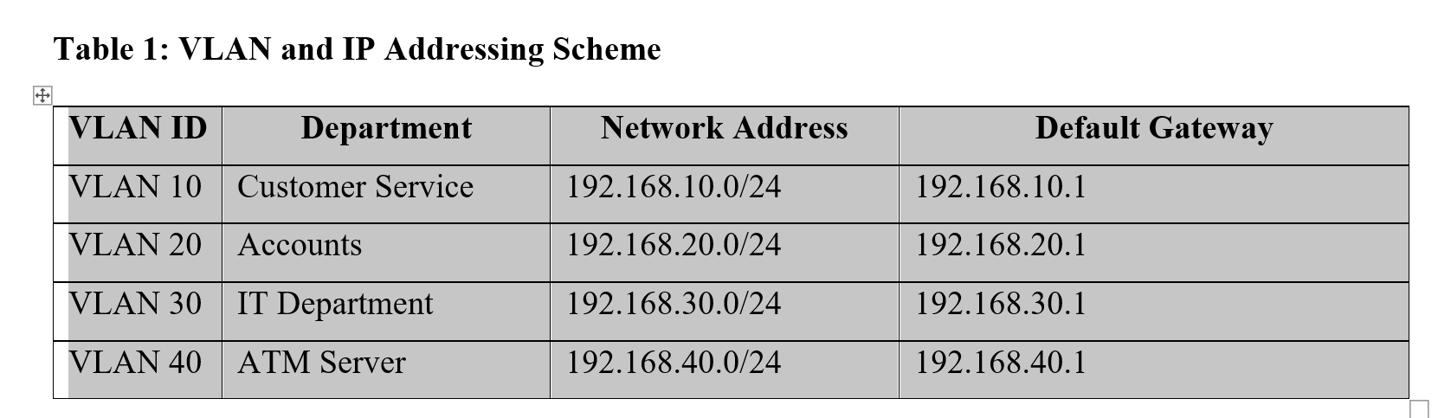

Table 2: Device IP Address Allocation
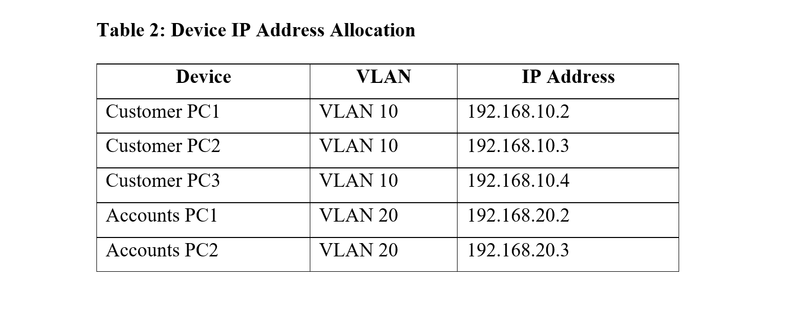
Each device was configured with:
• IP Address
• Subnet Mask (255.255.255.0)
• Default Gateway
This configuration enabled communication within the same VLAN and through the router for inter-VLAN communication.
NETWORK TOPOLOGY DESIGN
The network topology for this project was designed to represent a small enterprise banking environment using Cisco Packet Tracer. The design consists of one router, one switch, multiple departmental computers, and a server/ATM network. The aim of the topology is to demonstrate how VLANs can be used to segment an enterprise network into separate departments while allowing controlled communication through Inter-VLAN Routing.
The topology uses a star-based network design where all end devices are connected to a central switch. The switch is connected to a router through a trunk link. The router performs Inter-VLAN Routing using the Router-on-a-Stick method, which allows devices in different VLANs to communicate through router subinterfaces.
The network was divided into four major VLANs:
VLAN ID | VLAN Name | Department | Network Address
VLAN 10 | Customer_Service | Customer Service Department | 192.168.10.0/24
VLAN 20 | Accounts | Accounts Department | 192.168.20.0/24
VLAN 30 | IT | IT Department | 192.168.30.0/24
VLAN 40 | Server | Server/ATM Network | 192.168.40.0/24
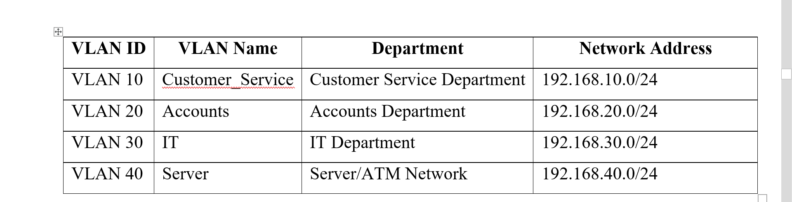

Logical Network Diagram:
Internet / External Network
|
Router
Router-on-a-Stick
|
Trunk Link
|
Switch
|
| | | |
VLAN 10 VLAN 20 VLAN 30 VLAN 40
Customer Service Accounts IT Dept. Server/ATM
192.168.10.0/24 192.168.20.0/24 192.168.30.0/24 192.168.40.0/24

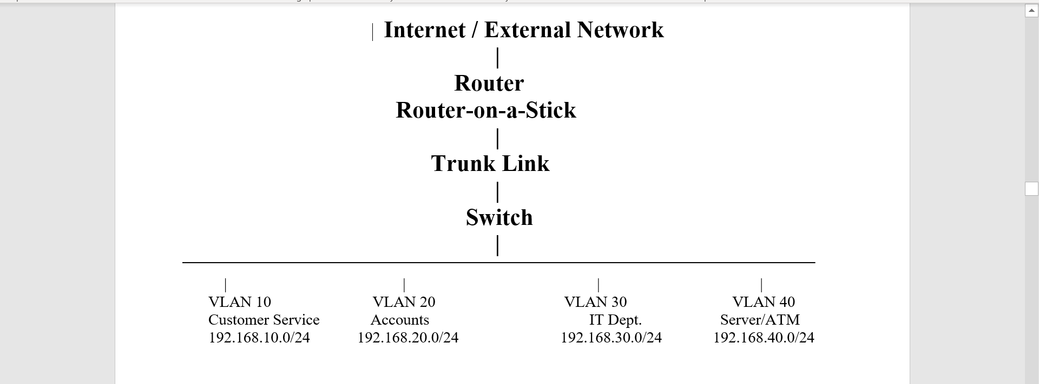
The router is responsible for routing traffic between VLANs. Each VLAN has a unique default gateway configured on the router subinterface. The switch is responsible for VLAN creation, VLAN naming, port assignment, and trunk configuration.

Topology Components:
Device | Function
Router | Provides Inter-VLAN Routing
Switch | Provides VLAN segmentation and port assignment
Customer Service PCs | End devices in VLAN 10
Accounts PCs | End devices in VLAN 20
IT Department PCs | End devices in VLAN 30
ATM/Server | Critical resource in VLAN 40
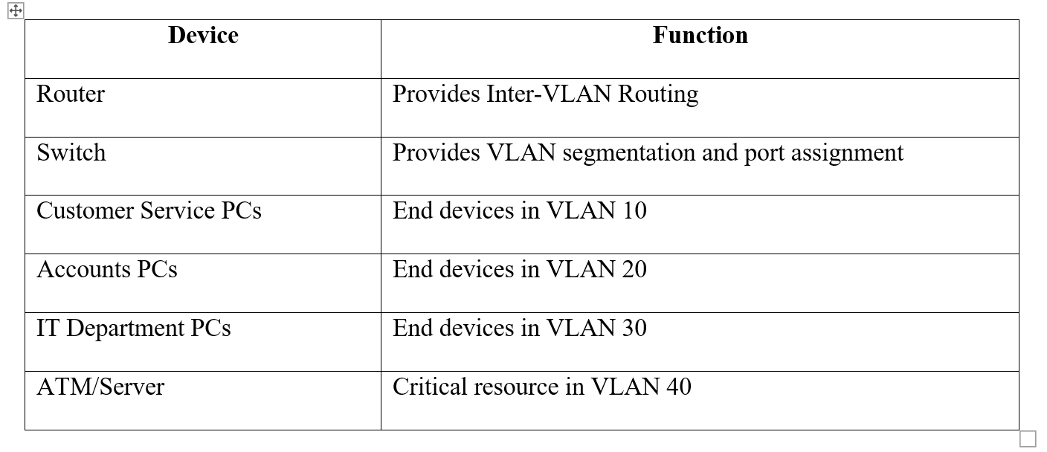
The topology was designed to improve network security, reduce broadcast traffic, and separate departments based on their roles. For example, Customer Service users were placed in VLAN 10, Accounts users in VLAN 20, IT users in VLAN 30, and critical server/ATM resources in VLAN 40.
This design supports the principle of network segmentation because each department operates in a separate broadcast domain. Without Inter-VLAN Routing, devices in one VLAN cannot communicate with devices in another VLAN. Controlled communication is enabled only through the router, where security rules such as Access Control Lists (ACLs) can be applied.
Security Benefits of the Topology:
• Separates departments into different VLANs.
• Reduces unnecessary broadcast traffic.
• Prevents unrestricted access between departments.
• Allows security policies to be applied at the router.
• Protects sensitive departments such as IT and Server/ATM networks.
• Improves network performance and manageability.
Figure 1: Network Topology
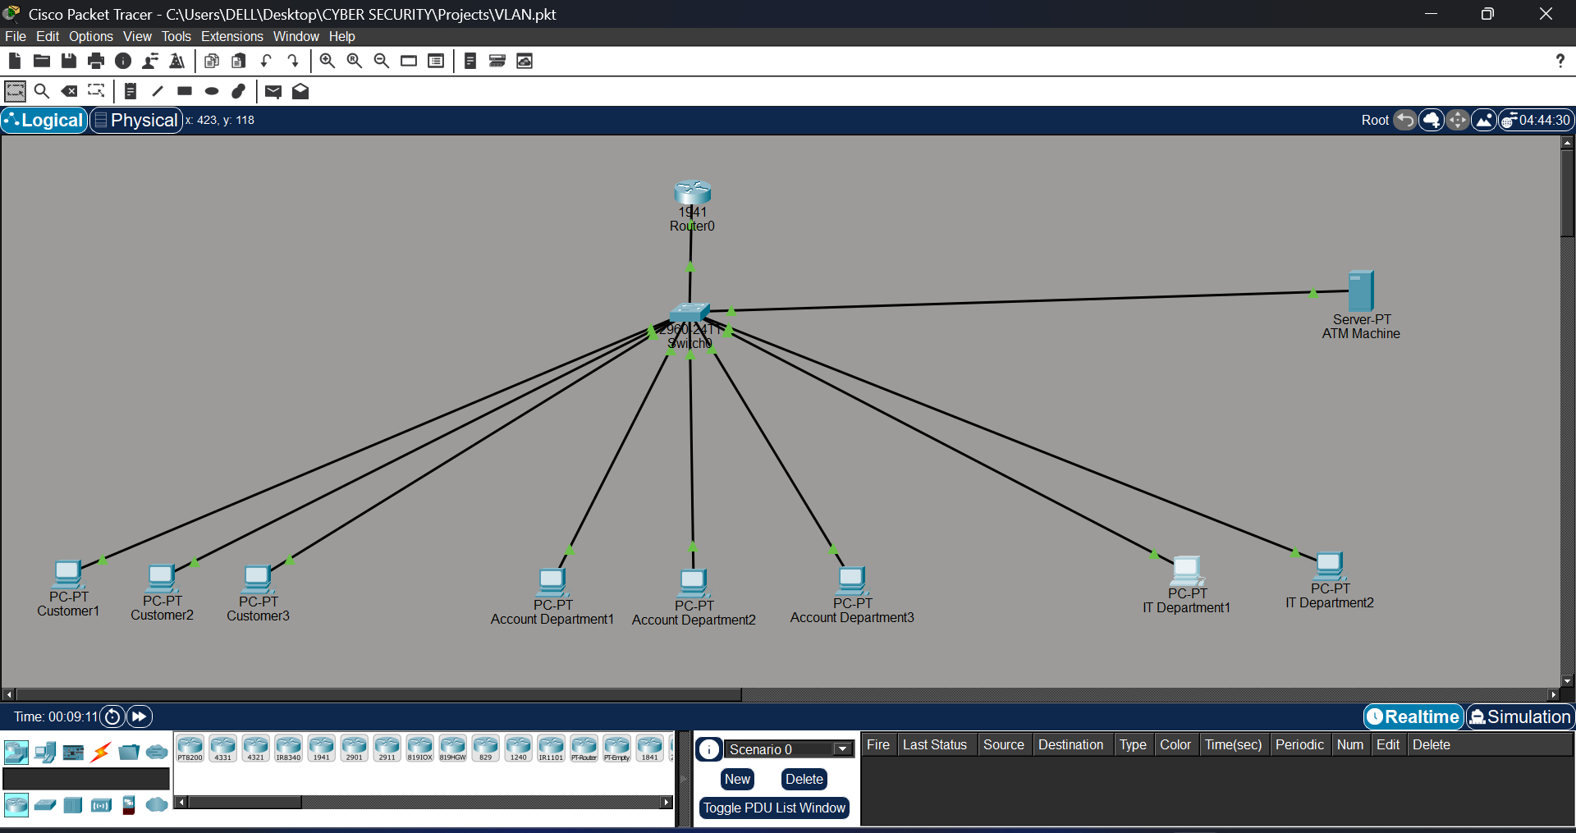

VLAN DESIGN AND CONFIGURATION
Virtual Local Area Networks (VLANs) were implemented to logically segment the enterprise network into separate departments. VLAN segmentation reduces broadcast traffic, improves network performance, and enhances security by isolating users and resources into distinct network segments.
Four VLANs were created to represent the various departments within the banking environment:
Table 3: VLAN Design
VLAN ID | VLAN Name | Department | Network Address
VLAN 10 | CUSTOMER | Customer Service | 192.168.10.0/24
VLAN 20 | ACCOUNTS | Accounts Department | 192.168.20.0/24
VLAN 30 | IT | Information Technology | 192.168.30.0/24
VLAN 40 | SERVER | ATM/Server Network | 192.168.40.0/24
The switch ports were assigned to their respective VLANs to ensure proper departmental separation.
Port Assignment:
• Fa0/2 – Fa0/4 → VLAN 10 (Customer Service)
• Fa0/5 – Fa0/7 → VLAN 20 (Accounts)
• Fa0/8 – Fa0/9 → VLAN 30 (IT)
• Fa0/10 → VLAN 40 (ATM/Server)
The VLAN configuration was verified using the command:
show vlan brief
The output confirmed that all VLANs were successfully created and that the correct ports were assigned to their designated VLANs.

Figure 2: VLAN Configuration (show vlan brief)
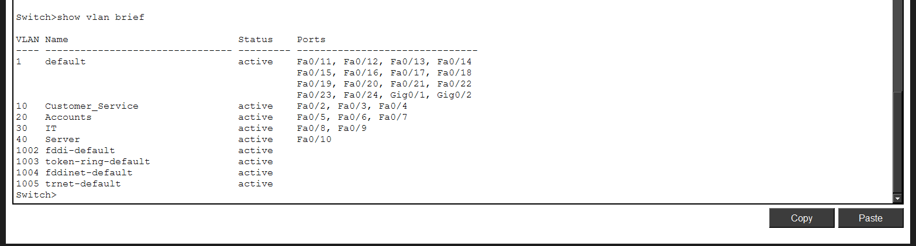

IP ADDRESSING PLAN
An organized IP addressing scheme was developed to provide unique network segments for each VLAN. Each department was assigned a dedicated subnet, ensuring efficient traffic management and simplified network administration.
Table 4: VLAN IP Addressing Scheme
VLAN ID | Department | Network Address | Default Gateway
VLAN 10 | Customer Service | 192.168.10.0/24 | 192.168.10.1
VLAN 20 | Accounts | 192.168.20.0/24 | 192.168.20.1
VLAN 30 | IT Department | 192.168.30.0/24 | 192.168.30.1
VLAN 40 | ATM/Server Network | 192.168.40.0/24 | 192.168.40.1
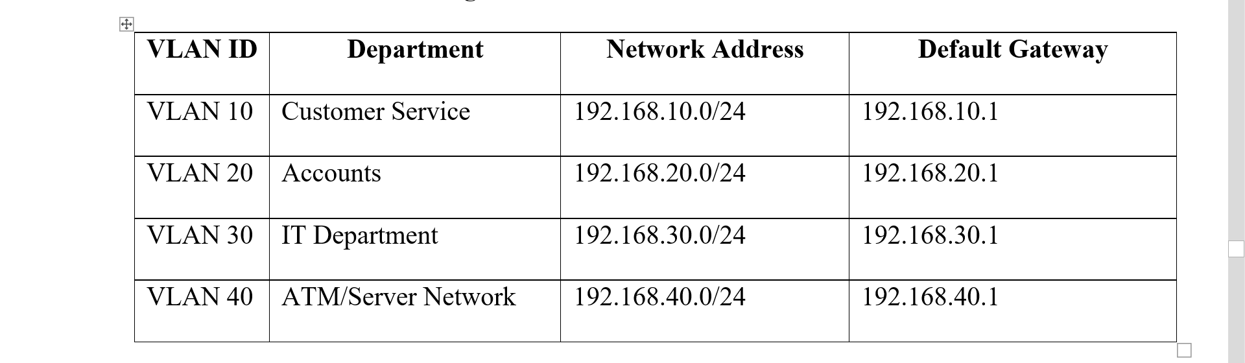
Device Address Allocation:
Device | VLAN | IP Address
Customer PC1 | VLAN 10 | 192.168.10.2
Customer PC2 | VLAN 10 | 192.168.10.3
Customer PC3 | VLAN 10 | 192.168.10.4
Accounts PC1 | VLAN 20 | 192.168.20.2
Accounts PC2 | VLAN 20 | 192.168.20.3
Accounts PC3 | VLAN 20 | 192.168.20.4
IT PC1 | VLAN 30 | 192.168.30.2
IT PC2 | VLAN 30 | 192.168.30.3
ATM Server | VLAN 40 | 192.168.40.2
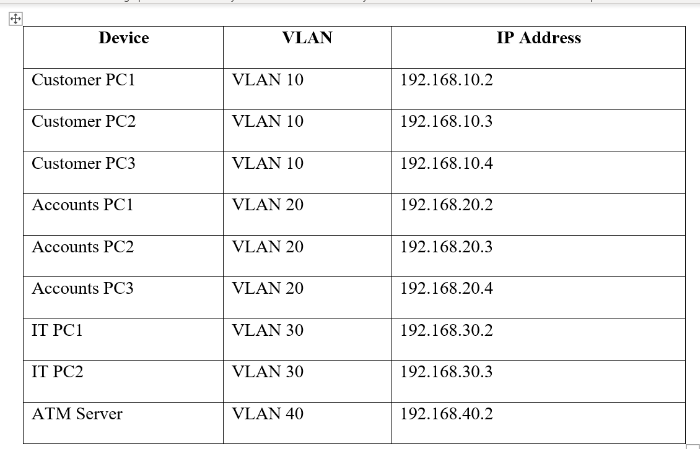
Each device was configured with:
• IP Address
• Subnet Mask (255.255.255.0)
• Default Gateway
This addressing plan ensured that devices could communicate within their VLAN and reach other authorized VLANs through the router.
INTER-VLAN ROUTING CONFIGURATION
Since VLANs create separate broadcast domains, devices located in different VLANs cannot communicate directly. To enable communication between departments while maintaining network segmentation, Inter-VLAN Routing was implemented using the Router-on-a-Stick technique.
Router-on-a-Stick is a method where a single physical router interface is divided into multiple logical subinterfaces. Each subinterface is assigned to a VLAN and acts as the default gateway for that VLAN.
The following router subinterfaces were configured:
Subinterface | VLAN | Gateway Address
G0/0.10 | VLAN 10 | 192.168.10.1
G0/0.20 | VLAN 20 | 192.168.20.1
G0/0.30 | VLAN 30 | 192.168.30.1
G0/0.40 | VLAN 40 | 192.168.40.1
IEEE 802.1Q encapsulation was used to identify VLAN traffic.
A trunk connection was configured between the switch and router to carry traffic from all VLANs across a single physical link.
The trunk configuration was verified using:
show interfaces trunk
The router configuration was verified using:
show ip interface brief
The successful output confirmed that all subinterfaces were operational and correctly assigned.
Figure 3: Trunk Configuration
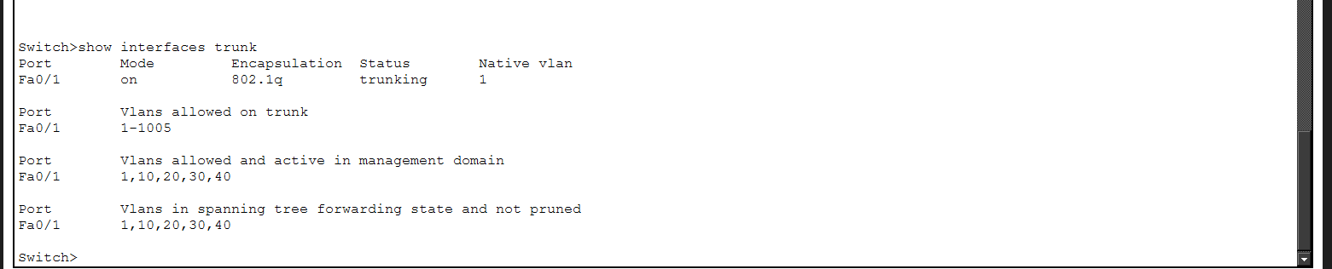
Figure 4: Router Subinterface Configuration
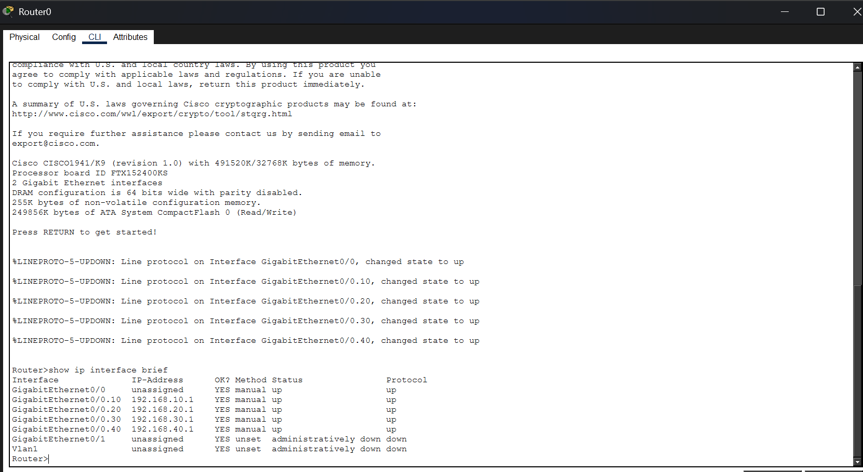

SECURITY IMPLEMENTATION (ACCESS CONTROL LISTS)
Security is one of the primary reasons for implementing VLAN segmentation in enterprise environments. To further strengthen the network, an Extended Access Control List (ACL) was configured on the router.
The ACL was designed to enforce departmental security policies and restrict unauthorized access to sensitive resources.
The following rules were implemented:
• Customer Service VLAN was denied access to the IT Department VLAN.
• Accounts Department VLAN was permitted access to the ATM/Server VLAN.
• IT Department VLAN was granted unrestricted access to all VLANs.
• General network communication was permitted where no restrictions existed.
ACL Policy Summary
Source VLAN | Destination VLAN | Action
Customer Service | IT Department | Deny
Accounts | ATM Server | Permit
IT Department | All VLANs | Permit
Others | Authorized Networks | Permit
Security Benefits:
• Prevents unauthorized access.
• Protects sensitive systems.
• Reduces insider threats.
• Enforces least-privilege access.
• Improves network security posture.
The ACL configuration was verified using:
show access-lists
Testing confirmed that Customer Service users could not access IT systems, while authorized departments could communicate successfully.
Figure 5: ACL Configuration and Verification
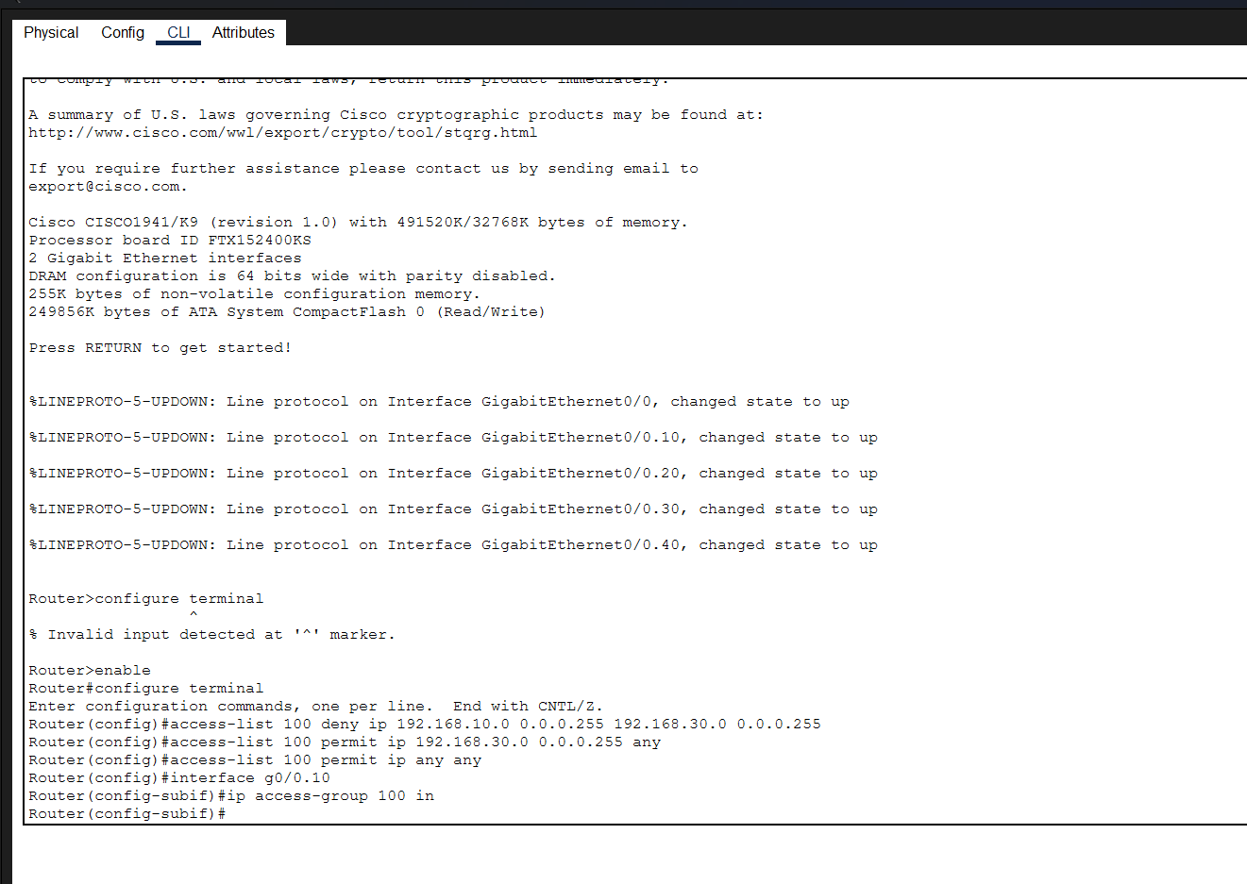
PROJECT VALIDATION AND TESTING RESULTS
After completing the network configuration, several tests were performed to verify functionality, connectivity, security, and compliance with project requirements.
VLAN Verification
Command Used:
show vlan brief
Result:
All VLANs were successfully created and assigned the correct switch ports.
Status: PASS
Trunk Verification
Command Used:
show interfaces trunk
Result:
The trunk link successfully carried VLAN 10, VLAN 20, VLAN 30, and VLAN 40 traffic.
Status: PASS
Router Verification
Command Used:
show ip interface brief
Result:
All router subinterfaces were operational and assigned the correct IP addresses.
Status: PASS
Connectivity Testing
Test 1:
Customer PC1 → Customer PC2
Result:
Successful communication.
Status: PASS
Test 2:
Customer PC1 → Accounts PC1
Result:
Successful communication through Inter-VLAN Routing.
Status: PASS
Test 3:
Accounts PC1 → ATM Server
Result:
Successful communication.
Status: PASS
Test 4:
Customer PC1 → IT PC1
Result:
Access denied by ACL.
Status: PASS
Table 5: Validation Summary
Test | Result
VLAN Creation | PASS
Port Assignment | PASS
Trunk Configuration | PASS
IP Addressing | PASS
Inter-VLAN Routing | PASS
ACL Enforcement | PASS
Connectivity Testing | PASS
Security Policy Verification | PASS
The successful completion of all validation tests confirmed that the network was functioning correctly and securely.
Figure 6: Network Testing Results
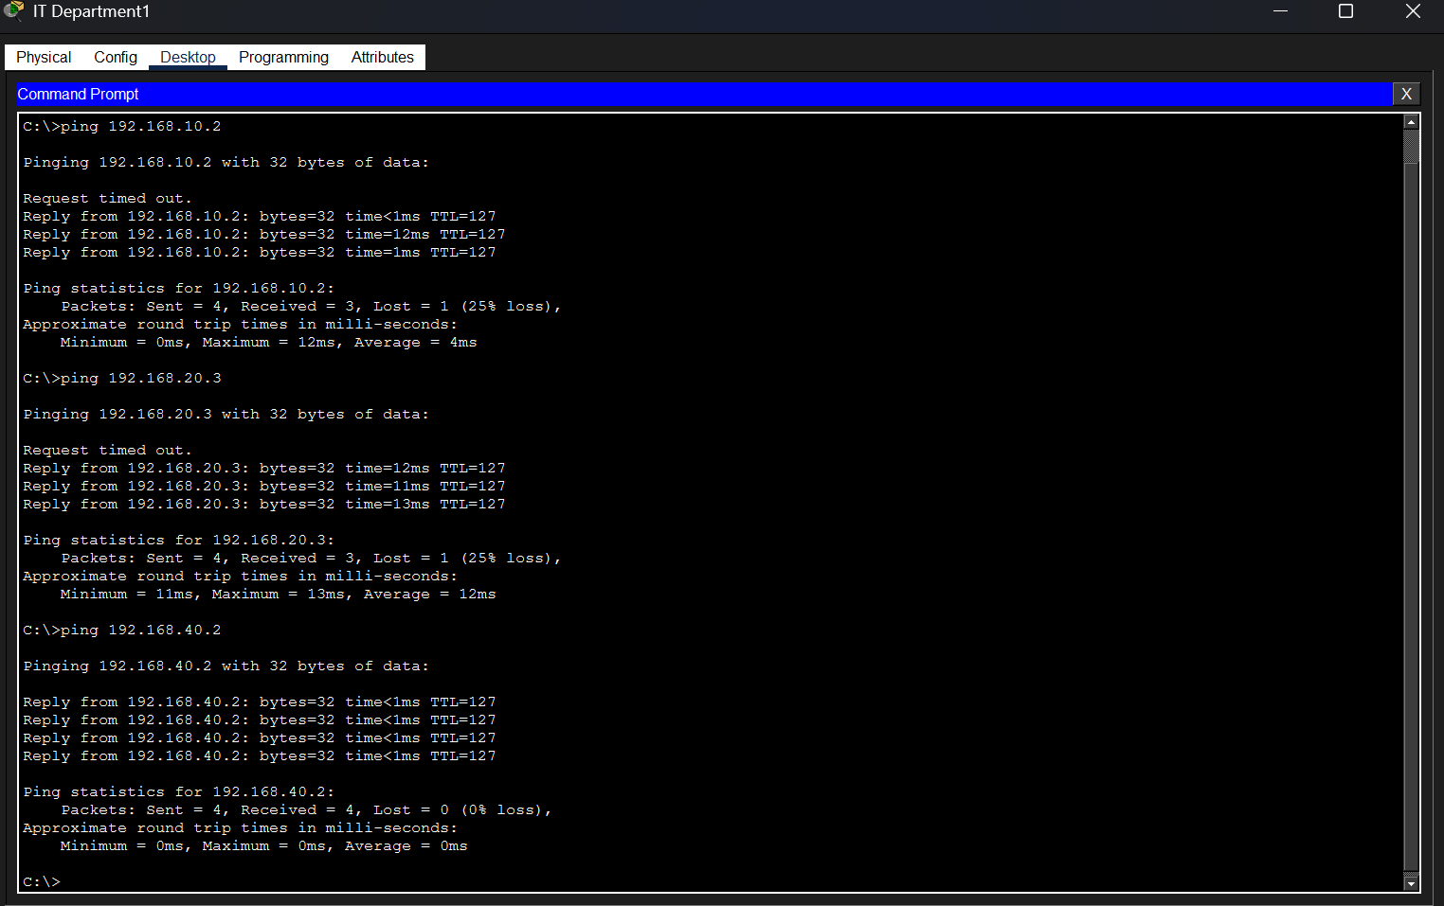
CYBERSECURITY SIGNIFICANCE OF THE PROJECT
Network segmentation is a fundamental cybersecurity practice used by organizations to reduce risk and protect critical resources. This project demonstrates how VLANs and Access Control Lists can be combined to create a secure and manageable enterprise network.
Benefits of VLAN Segmentation
• Reduces broadcast traffic.
• Improves network performance.
• Limits lateral movement by attackers.
• Isolates sensitive departments.
• Enhances administrative control.
Benefits of Access Control Lists
• Restricts unauthorized access.
• Protects critical assets.
• Enforces security policies.
• Supports compliance requirements.
• Reduces insider threats.
Importance in Banking Environments
Financial institutions handle highly sensitive information including customer records, transaction data, ATM communications, and internal business operations. Unauthorized access to these resources can result in financial loss, reputational damage, and regulatory penalties.
The implementation of VLANs and ACLs provides multiple layers of security by ensuring that users only have access to the resources necessary for their job functions.
The project demonstrates several cybersecurity principles:
• Least Privilege
• Defense in Depth
• Network Segmentation
• Access Control
• Secure Resource Isolation
These principles are widely adopted in modern enterprise networks and cybersecurity frameworks.
CONCLUSION
This project successfully designed and implemented a secure enterprise network using VLANs, Inter-VLAN Routing, and Access Control Lists within Cisco Packet Tracer. The network was segmented into four logical departments: Customer Service, Accounts, Information Technology, and ATM/Server Infrastructure.
VLAN implementation provided effective network segmentation, reduced broadcast traffic, and improved overall security. Inter-VLAN Routing enabled controlled communication between departments while maintaining separation of network resources. Access Control Lists were applied to enforce security policies and restrict unauthorized access to sensitive systems.
Comprehensive testing and verification confirmed that VLAN creation, trunk configuration, IP addressing, Inter-VLAN Routing, and ACL enforcement were functioning as intended. Authorized departments successfully communicated with required resources, while restricted access policies were enforced correctly.
The project demonstrated the practical application of enterprise networking concepts and cybersecurity controls used in real-world organizations. Through VLAN segmentation, routing configuration, and access control implementation, the network achieved improved security, scalability, performance, and manageability.
Overall, the project successfully met all objectives and provided valuable hands-on experience in enterprise network design, implementation, troubleshooting, and cybersecurity best practices.

